**BD LAB(LAB PRGM3)**

Name: Abhiruchi Verma

USN: 1NT19IS002

**Driver code**

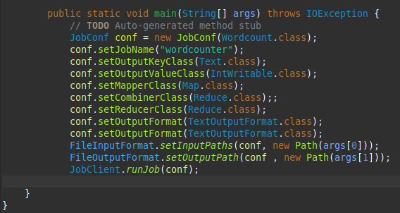

**Mapper code**

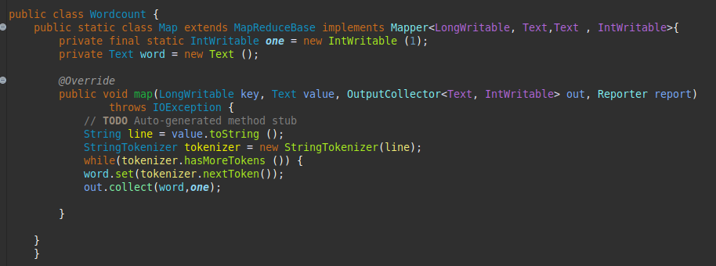

**Reducer code**

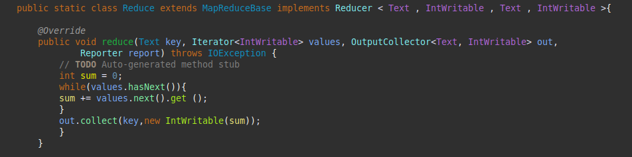

**Start HADOOP**

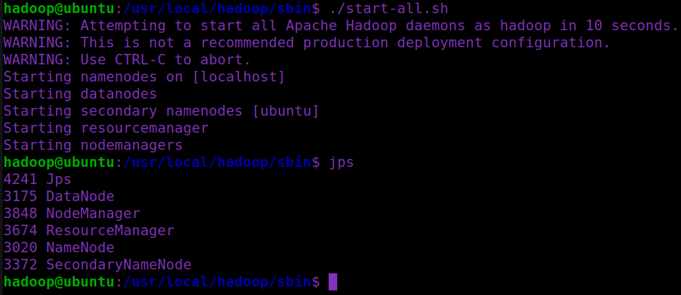

**Make input and output directories**

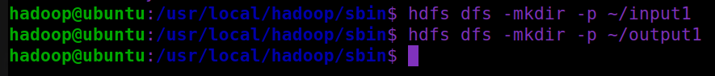

**Create input text file and add data**



**Add the jar**



**Displaying the output file on terminal**

